The Holy Complete Portal

Bible

**Index**

**Dealer Enrollment Portals**

Applications in these portals need to be signed off Once a day:

Yard Card <https://yardcard.tdpartnershipprograms.com/#/>

Cub Cadet <https://cubcadet.tdpartnershipprograms.com/#/>

Toro eXmark <https://toroexmark.tdpartnershipprograms.com/#/>

TD Complete <https://enroll.tdcomplete.com/#/>

AVB Complete <https://enroll.tdcomplete.com/avb#/>

**Steps to sign off on an Application**

These steps are the same for all DEPs

* Use your LDAP credentials to login

*Make sure you have Login selected not register

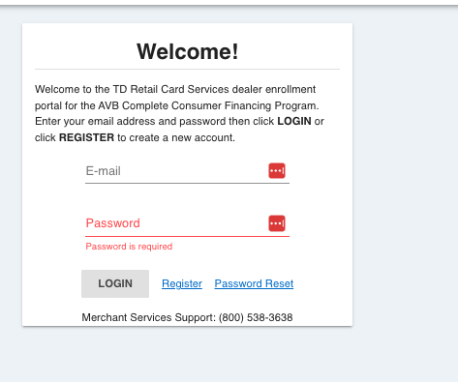

2. Easiest way to located new submitted applications go to the search bar and type submitted. If no applications appear, that means no applications have been submitted.

*Please note that for TDC & Yard Card DEPs there are applications from previous years, it is imperative that we DO NOT sign off on these applications. TD will not be happy if they are sent over.

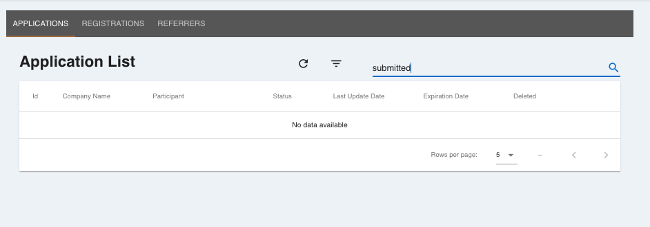

3. If a CURRENT YEAR application appears under submitted go to the Action button on the right side, click. Then click on sign off.

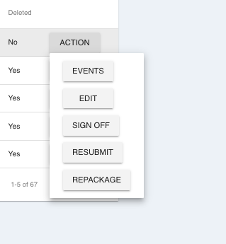

You will get a prompt to confirm you would like to sign off on the application, click ok.

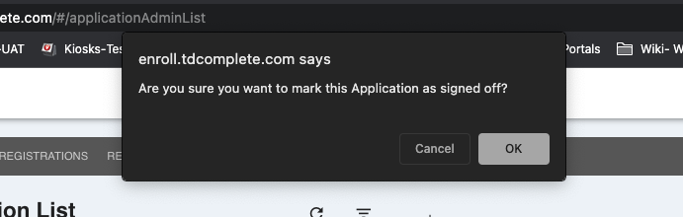

**Dealer Confirmation Trainings**

*I only take note of AVB Training Confirmations

They are delivered via email from noreplies via TD Complete Notices with the subject line being Congratulations on completing 2023 AVB Credit Card Training (screenshot below)

It is important to note that we only receive the block code files removals from TD Tuesday-Saturday. Any training confirmations that are completed Late Saturday morning to Monday, the welcome emails should be sent out Tuesday.

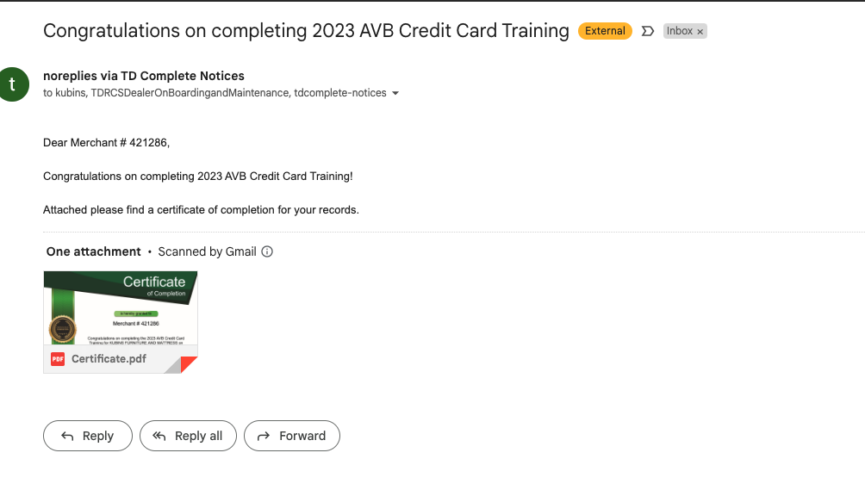

I keep track of the retailer name on this sheet [AVB Merchant Training & Credential Sheet](https://docs.google.com/spreadsheets/d/1XRTnztEf87ifyT-kvE7BXeUDwvtVJCl9zho07BoDZt4/edit#gid=9493278).

Tab Explanation:

Training Complete Need to Send Credentials: This is where I notate the retailer training confirmations. This is my trigger to send the welcome email out. I only notate the merchant name, date they completed the training and any notes. What I mean by notes is if we receive the TD credentials the same day as the training confirmation. I keep track of this and report it back to TD only with my monthly analytics.

Credentials Sent 2023: After I sent the welcome email, I move the retailer information from the previous tab to this one.

**AVB TD Credentials**

Credential Emails will be delivered by Hannah Etheridge or Natalia Herrera

Example below

*Its easier if you open then in google sheets

First thing I do when I open the sheet is hide columns F & H - we don't need them

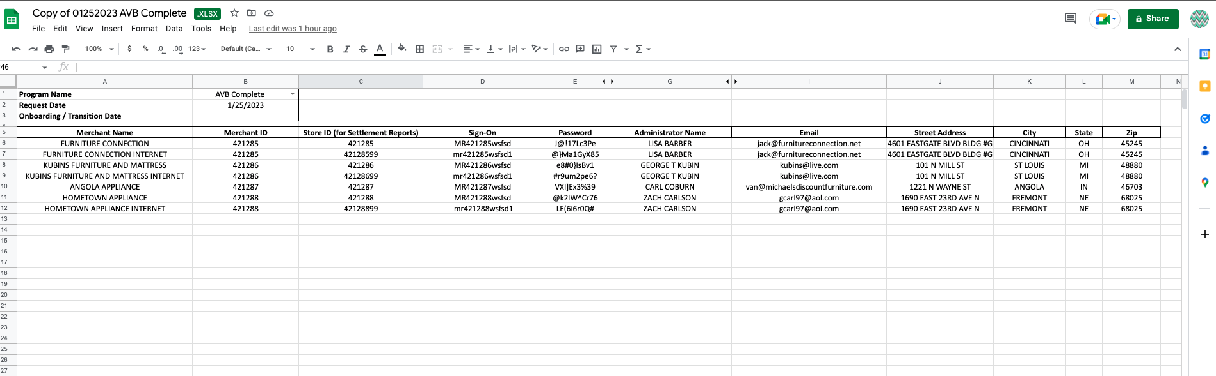

**Adding them as a new domain in console** <https://avb-complete.com/console/?=r1674757141373#/dashboards/default>

Left hand menu find Domains, click

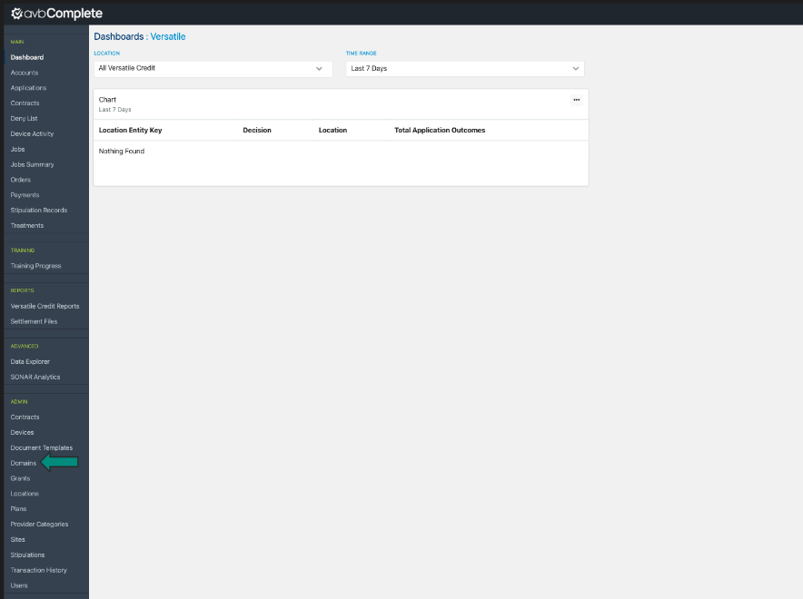

To add a new domain click +Add

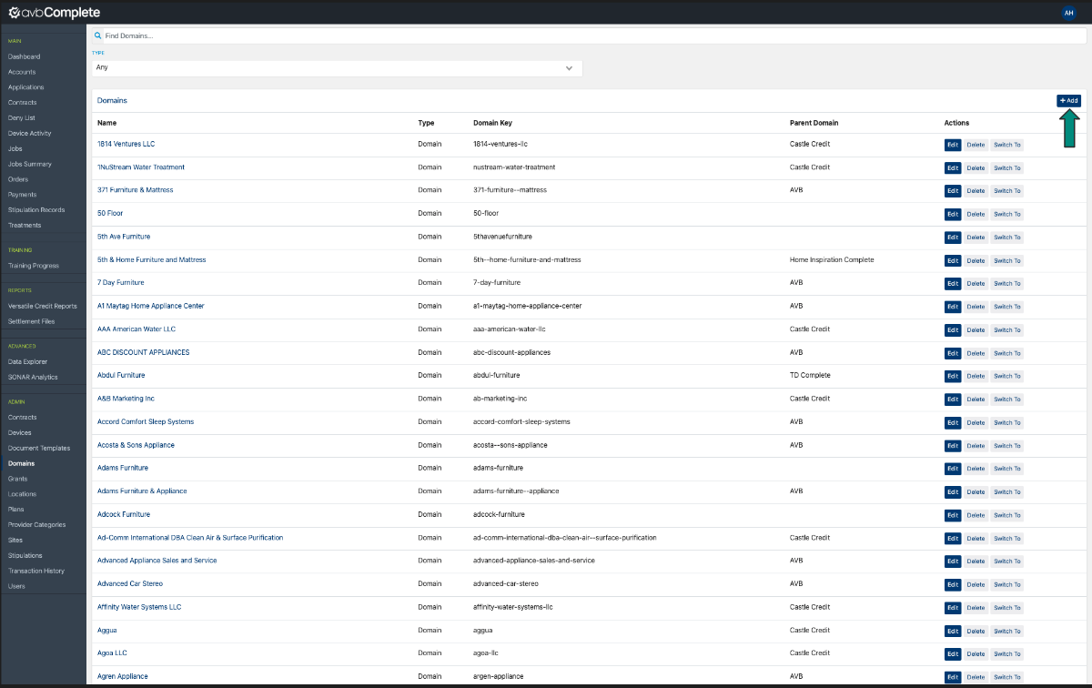

Input the information needed for the required fields

-Entity key will ALWAYS be all 0s

-Match Times zone to the address provided on the TD credentials

Click save when all fields have been completed.

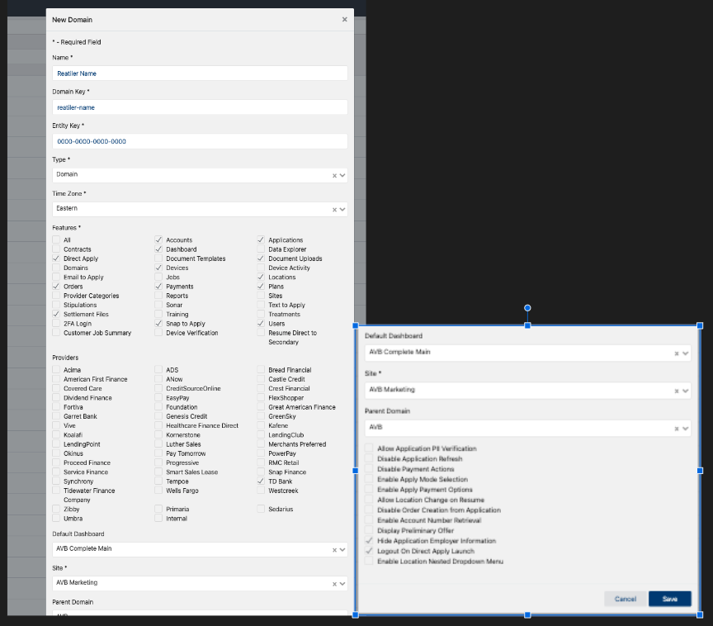

**5/24/24 UPDATE:**

For Type select Merchant now

For Features Select Reports

**Assigning Buying Groups**

The page will refresh and the domain you just added will be at the very bottom. The retailer name is a hyperlink, click it. You will be brought to a page similar to the below

*If this step is missed there will be no promotion plans appearing for the retailer

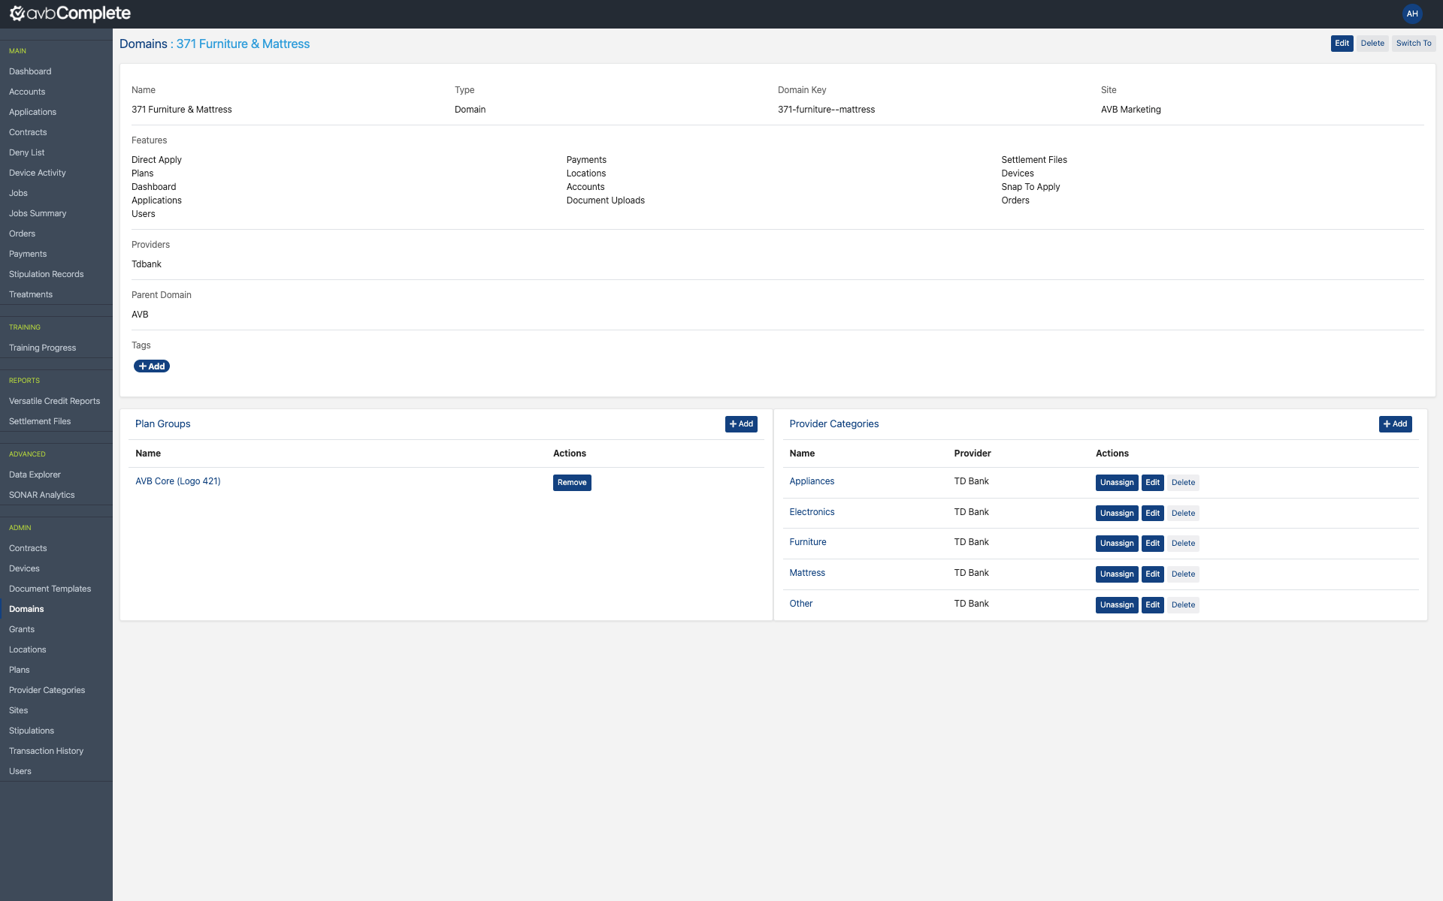

Go to the area that states plan groups, Click +Add

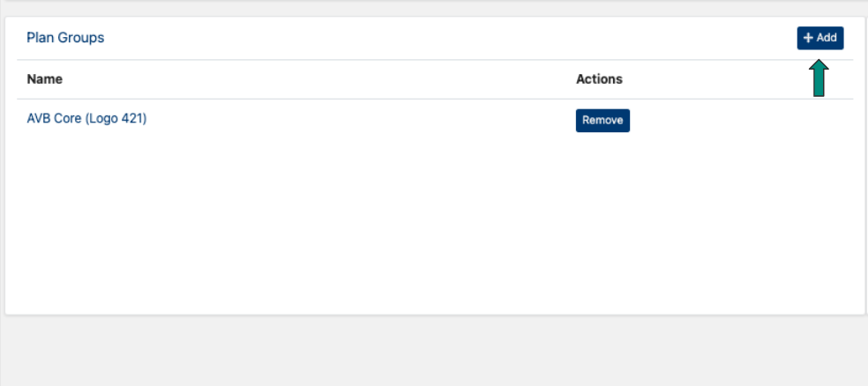

There are 7 different buying groups for AVB listed below:

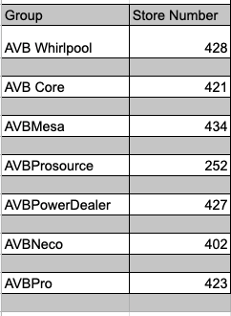

* The first 3 numbers of the TD Merchant Number tells what group the retailer will be enrolled in.

Matching the first three numbers to a buying group, then click select

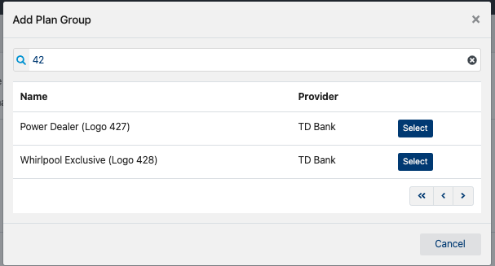

Click Yes

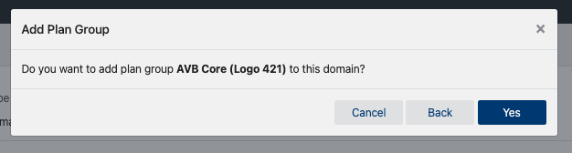

**Assigning Provider Categories**

To the right of where you assigned the buying group there will be a box labeled provider categories. Click + Add

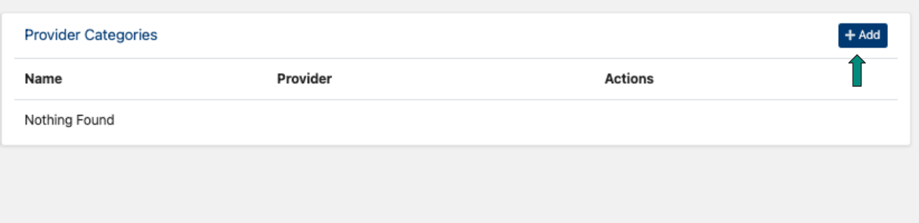

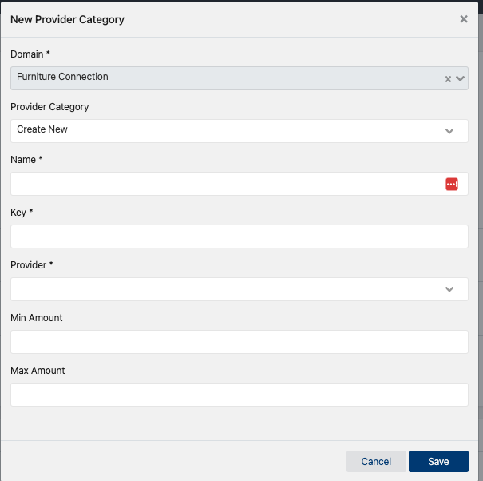

During the initial setup of a domain for AVB we only activate TD. The categories for TD will always be the below:

Appliances

Electronics

Furniture

Mattress

Other

**Fields that needs information entered:**

Name

Key- is where you would enter one of the categories above (appliances, electronics, etc)

Provider- TD Bank

Click Save

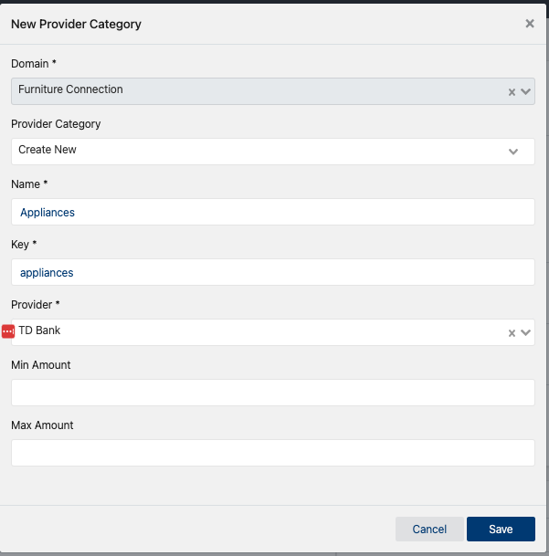

**\*This step will need to be repeated till all 5 categories are added. Once they are added it should be like the below.**

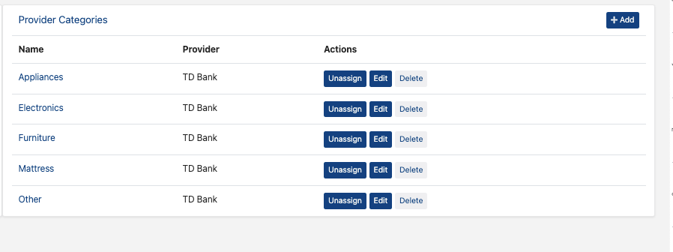

**Now you need to switch domain to the retailer you just added.**

**Switching to the Domain you just created**

Go to your initials at the top right corner in console

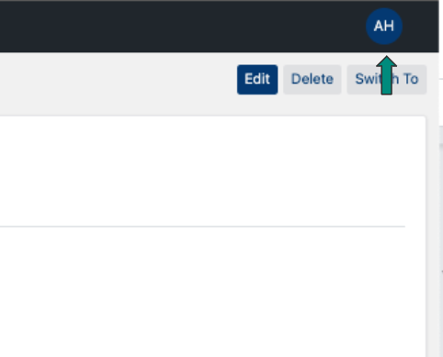

Locate the retailer you just added

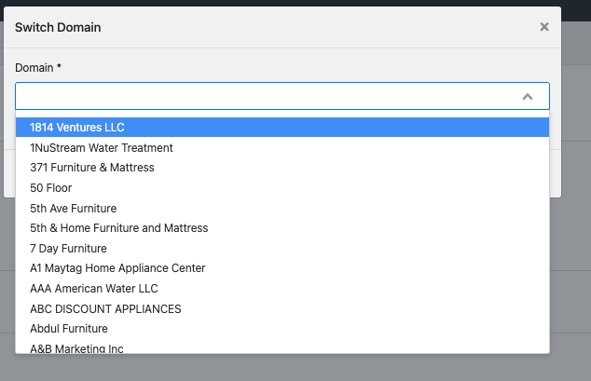

Once you locate their name, click the name and then click switch

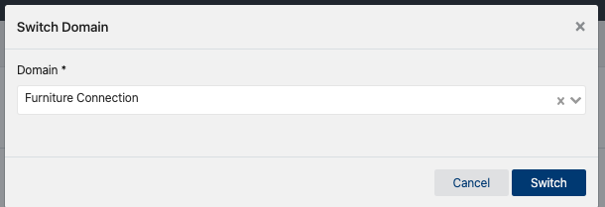

The retailer domain will load and you should now see the AVB Complete dashboard.

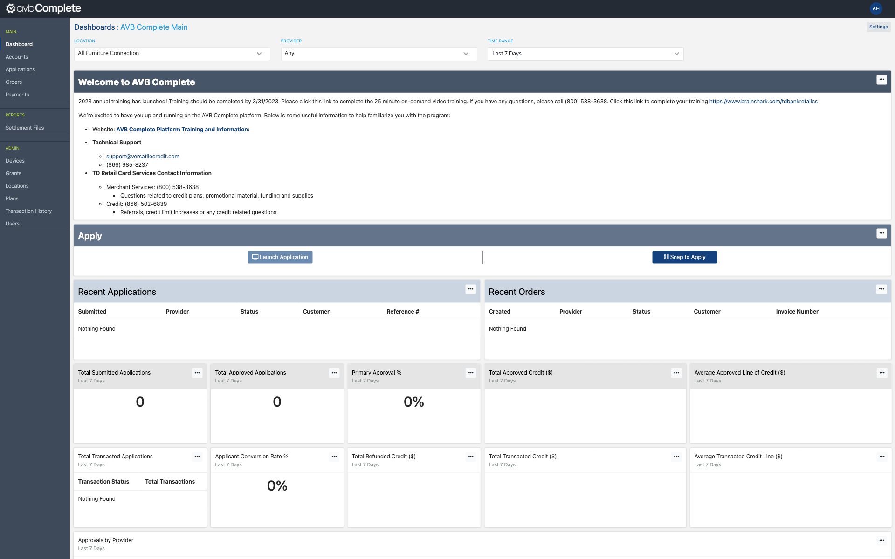

**If you do not see the AVB Complete dashboard it means a box was missed being checked when you were setting up the domain. Click here to go to the section if you need to double check.**

After you have switched to the new retailer you will need to assign the plan group.

Go to the left hand menu and click plans

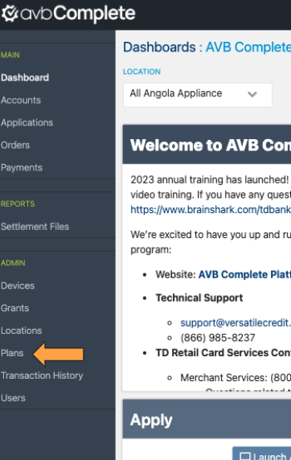

Click Manage Plan Schedule

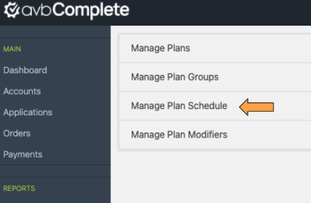

Click Batch Schedule

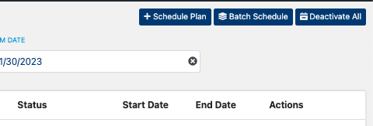

Select the appropriate plan group and click save

**\*This will match the same plan group you selected when creating the domain**

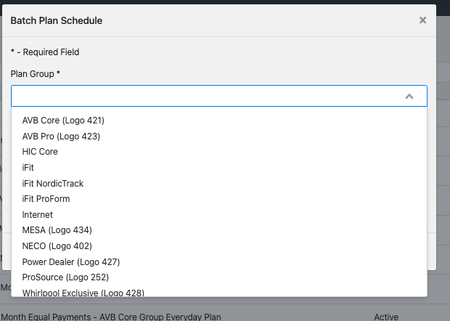

**Setting Up Locations**

Go to the left hand menu and select locations

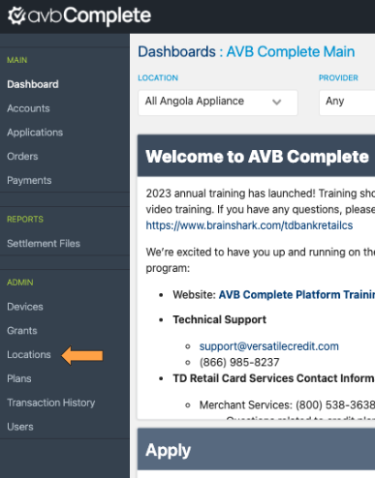

**Things to Know:**

* **Do not copy paste the names directly from the sheet that is sent by TD as they are in all CAPS. If this is done it will cause multiple errors in reporting and how things are pulled into the console.**

**\*This is only for the retailer name**

* **If a retailer has more than one location I do the retailer name followed by a dash then the town name. If the retailer has two locations in the same town use the street name instead.**
* **If you see two locations listed in the TD sheet that says they have the same address, this is allowed. They are the same roofline however they have two different Tax IDs assigned to them and therefore two different store #s because the checking accounts tied to them on the TD side are different.**
* **Whatever you name the locations will be carried on to the sheet that is used to send Doug the TD credentials. Those instructions are below on page**
* **You will need to create a location labeled - Internet if there are internet credentials listed with a retailer.**

You will not have to update the group key, that will only be done by Doug.

To add a location click +Add on the right side

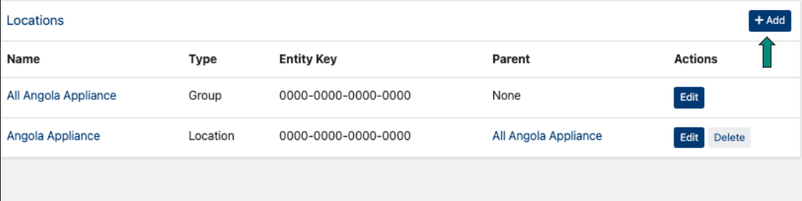

An iframe box will appear prompting you to enter the information

**What box will you enter information:**

-Name this is where you would put location name

*Make sure if you have to use the dash followed by town name to Include that as well

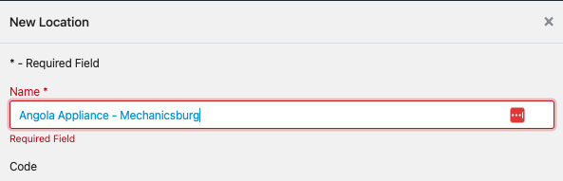

* Type: you will ALWAYS select location
* Channel: Instore is for in store locations and e-commerce is for Internet locations
* Entity Key: enter all 0s, Doug will update this with the admin key when he is done with the configuration.
* Time Zone: match to what Time zone the retailer is located in
* providers - Make sure you check the box for TD

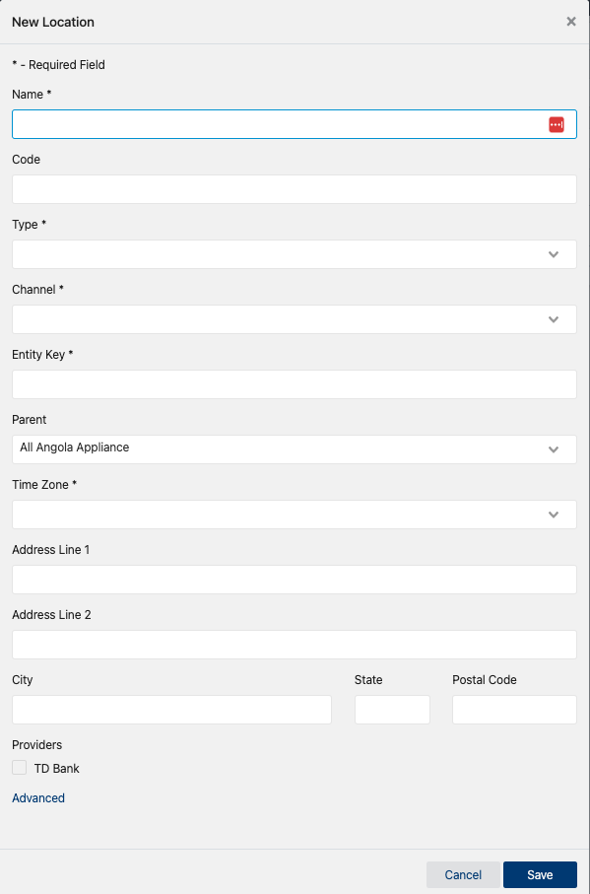

Then click save.

Repeat these steps for any other locations that need to be added under this retailer.

**Sending the Credentials over to Doug**

There are separate spreadsheet for AVB and TDC/Leer/HIC, links below

[AVB Merchant Credentials](https://docs.google.com/spreadsheets/d/1DG1iXzIah8ViCfco45qHmxazAJbEQCdR_n4V4K1H2IE/edit#gid=167157873)

For this spreadsheet it is used for new retailers as well as activating lenders for retailers as well.

[TD/Leer/HIC](https://docs.google.com/spreadsheets/d/1PJLI62WLkgqQ6mY4knv4eRGLXM6bZ7FcQ-nNMa5vV8g/edit#gid=0)

PFP credentials get sent over through this sheet

AVB Retailers:

I have created a template tab for the initial onboarding, labeled [Initial Retailer Onboarding Tab Template](https://docs.google.com/spreadsheets/d/1DG1iXzIah8ViCfco45qHmxazAJbEQCdR_n4V4K1H2IE/edit#gid=451152318)

Column Explanation:

A&B: Can be disregarded as these two columns are where Doug will paste the Admin Key after he is done with the configurations.

C - Merchant Name: This is where the retailer name goes. If the retailer has more than one location you should list the additional location names exactly as they appear in the location tab in the portal.

D - Address: This column can be copy and pasted directly from the sheet Td send.

E- Program: This is where you will put what program this retailer will be apart of. This will tell Doug what template he is to use during the configurations.



F-I: These four columns can be copy and pasted directly from the sheet TD provides.

On the template row 3 is for the internet location, the reason why is that there is no S2A key that will be needed so column A is grayed out. You can duplicate this tab and add the applicable information. You will need to update the tab name if you duplicate it. The tab numbers are in numeric order. After you have all the information entered, you can slack Doug letting him know that V175 (example #) is ready and he will take it from there.

**Welcome Emails**

Welcome emails will only need to be sent out for TDC, Leer and AVB Complete.

TDC & Leer use the same [template](https://docs.google.com/document/d/1teOSix8XUlksPon2dgLooA-74BbXoM0SMR64WPajN6w/edit)

AVB Complete [template](https://docs.google.com/document/d/1t1077xaWsR7UesbLvWJZpcYUz-n7_29wRH1eq5XyFrs/edit)

I have found that when I set up a domin and add a user its easier to complete the welcome sheet at this time, then I can download and save to my desktop.

Email for AVB retailers:

* CC’ Cam Woliver ([Cam.Woliver@td.com](mailto:Cam.Woliver@td.com)), Amine Karimi ([Amine.Karimi@td.com](mailto:Amine.Karimi@td.com)), Andrew Guasto ([Andrew.Guasto@td.com](mailto:Andrew.Guasto@td.com)), Ghinny Ashford ([Ginny.Ashford@td.com](mailto:Ginny.Ashford@td.com)),

Candace Coleman ([Candace.Coleman@td.com](mailto:Candace.Coleman@td.com)), Evan Cramer ([Evan.Kramer@td.com](mailto:Evan.Kramer@td.com)) & [Marlys Mead](mailto:mmead@versatilets.com)(mmead@versatilets.com)

Body of the email:

Hello (insert retailer name)

I have attached a few documents for you, the first being your welcome email.

This contains your temporary password as well as your access code for your store.

The next attachments are helpful guides, the first is a reference sheet on when to contact Versatile should you experience any issues.

There is also a guide on adding users to the portal and activating plans. If you attended a demo they discuss that you have the ability to deactivate plans or set limitations to plans the guide shows the steps to take to reactivate promotional plans.

There are several links to our knowledge center where there are numerous videos and other how-to documents.

Attachments:

These attachments get attached to EVERY AVB Welcome Email that is sent.

Welcome email Sheet (link above)

[Changing Locations](https://docs.google.com/presentation/d/1rmfExRBAEg9FIy3AwkE-_NuxFJZ3_yzkkH9AKZAH-og/edit#slide=id.g14da4e41163_0_0)

[Adding Users](https://docs.google.com/presentation/d/1mhzVPQdSf2f3E0MANNuhzTX01ntcN1rRYNvZwltfeHc/edit#slide=id.g172d65db90b_0_271)

[Resource Sheet](https://docs.google.com/presentation/d/1tDJSOcMpzPe1MM_IRhE-7gYEc6EH-Ob9o8xoM8FpfZs/edit#slide=id.p)

[Plan Management](https://docs.google.com/presentation/d/1ZOBFFa46_G6IqFePOO7d5InGLfYYD9J-8ROuQZdy5K4/edit#slide=id.g172d36e3c8d_0_0)

**AVB Internet Keys**

After Doug completes the configuration process a grant needs to be created.

**This step only needs to be done for NEW retailers. I have all other retailers who have been onboard up until this point completed**

From the main console page on the left hand menu find Grants and click

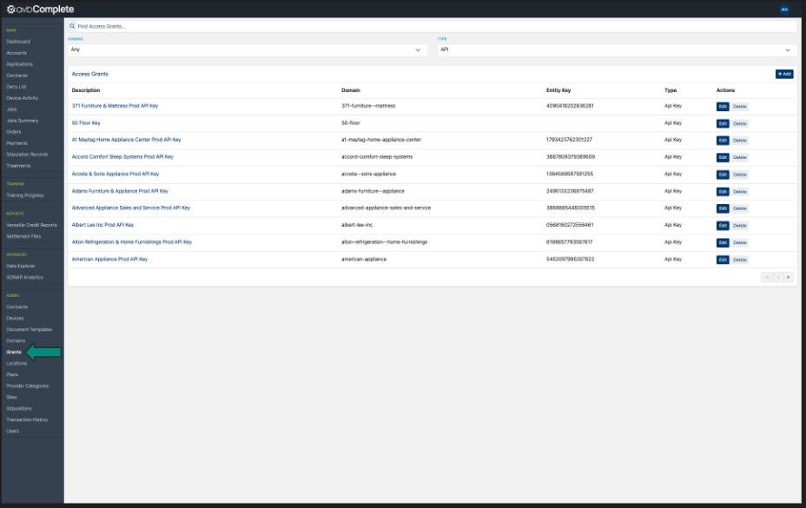

**At any time if you need to search through all of the pages make sure your domain dropdown says Any. It automatically defaults to Versatile Credit. Also if you click into a retailer and go back the domain will default back to Versatile Credit.**

**Double Check to Make sure there is not already a grant created**

If you are unsure if a grant has been created the dropdown box that says domain will allow you to search and verify this. Selecting a single domain will produce a page like the screenshot below

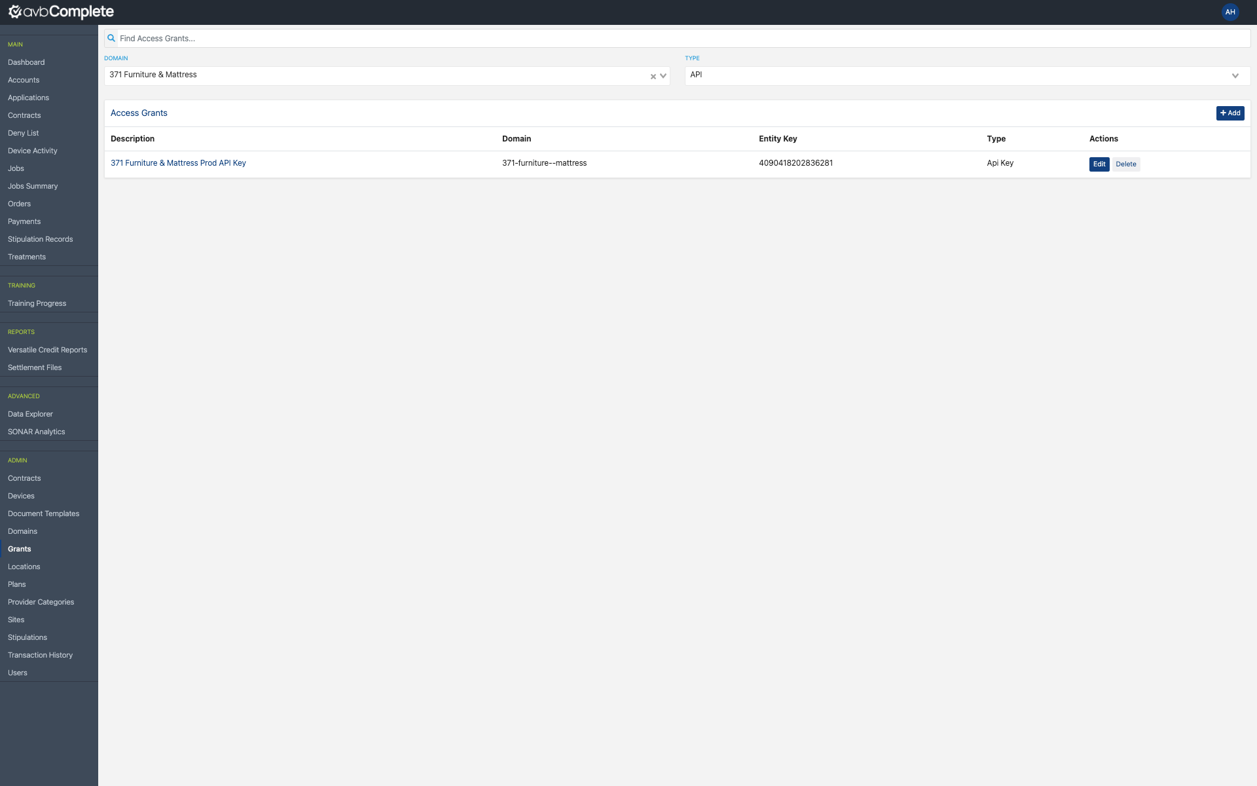

**Creating the Grant**

To create a grant click +Add on the right side of the screen

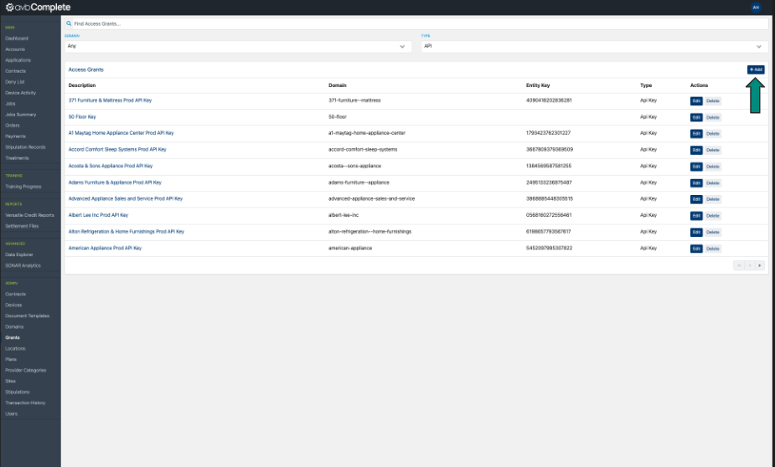

I have found for this step it is easiest to make sure you have the key open in Admin as well so you can copy and paste the information.

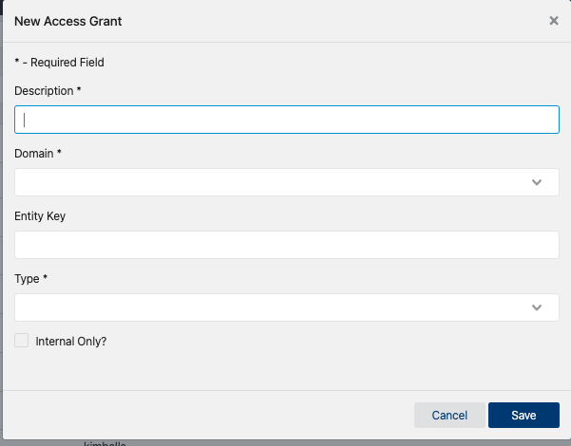

Description field - The retailer name followed by Prod API Key

Domain - Select the retailer that this Grant is for

Entity Key - This is where the Admin Internet Key number will be entered

Type - API

Then click save

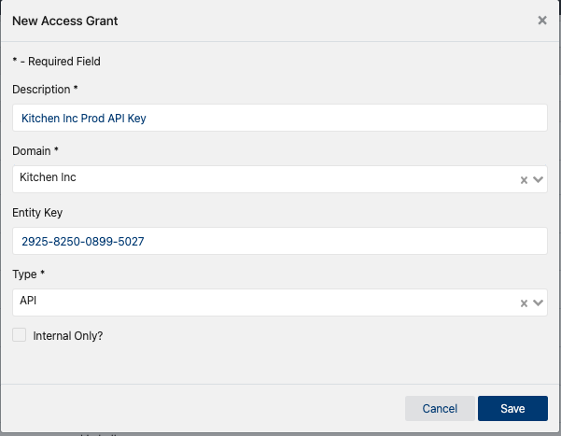

**Why does this need to be done?** If you click into the grant you just created you will see that a token is listed. This token along with the entity key/admin key is what is sent to AVB/Brandsource to integrate the retailer’s e-commerce piece. You do not have to worry about sending anything now, they will reach out when they are ready for the token and key.

**AVB Plan Management**

I have all plans update for current month but just in case. The promotion plan tracker will be sent by Craig McGuinness.

If a plan needs to be changed or added to make sure that the end date is inclusive the date we set in the portal must be the day after the sheet that is provided by TD.

**Accessing AVB Plans**

On the left hand menu find the Plans tab, click

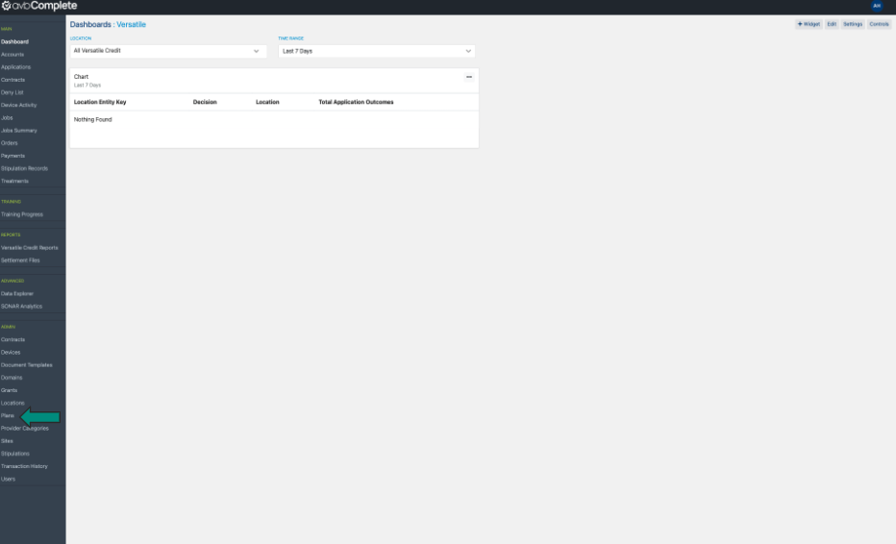

Then click Manage Plans

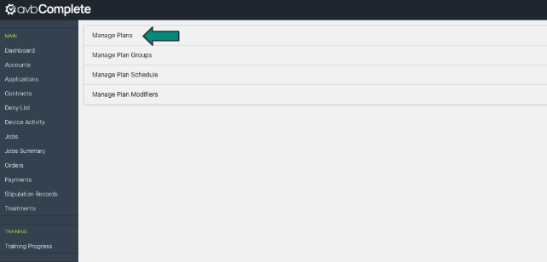

On this page you can search by individual plan number or filter down by provider.

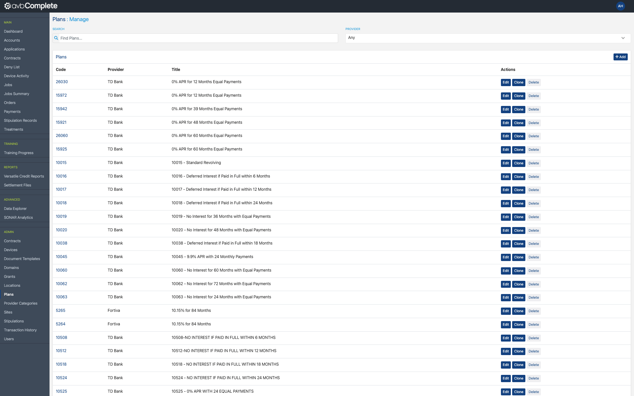

**Example of how the plans are sent over from Craig**

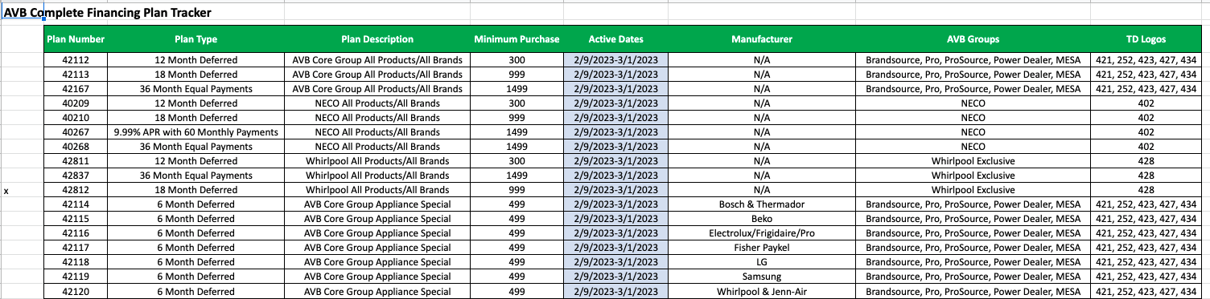

After you search or locate a plan, there are two ways to edit the information attached to it, both methods will get you the same results.

The first option is clicking the edit button under the Actions column (orange arrow)

The second option is clicking the hyperlink of the plan number

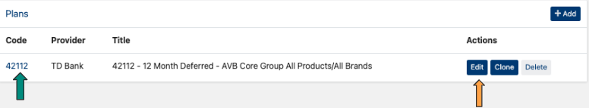

Option 1

After you click edit an ifram box will appear where you can make any adjustments.

If you do need to change infomratin for the plan the save button is located at the bottom

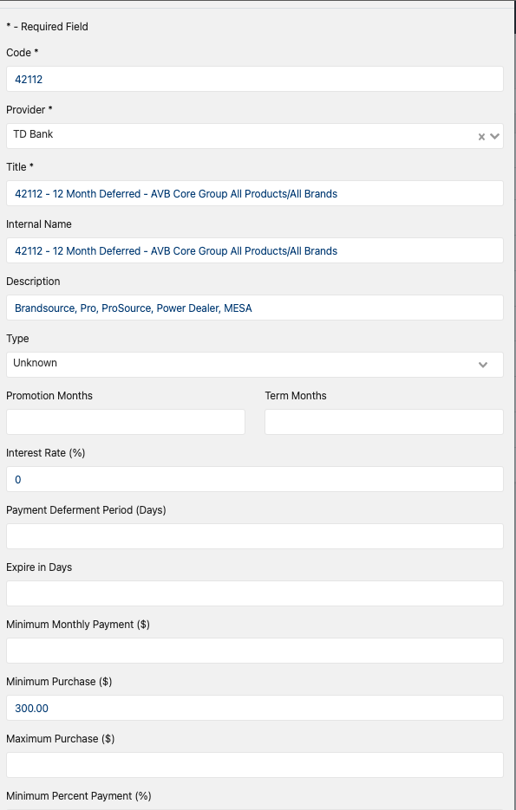

Option 2

After you click the hyperlink of the plan number you will see a page similar to the below.

If you need to make any changes click edit located in the up right corner

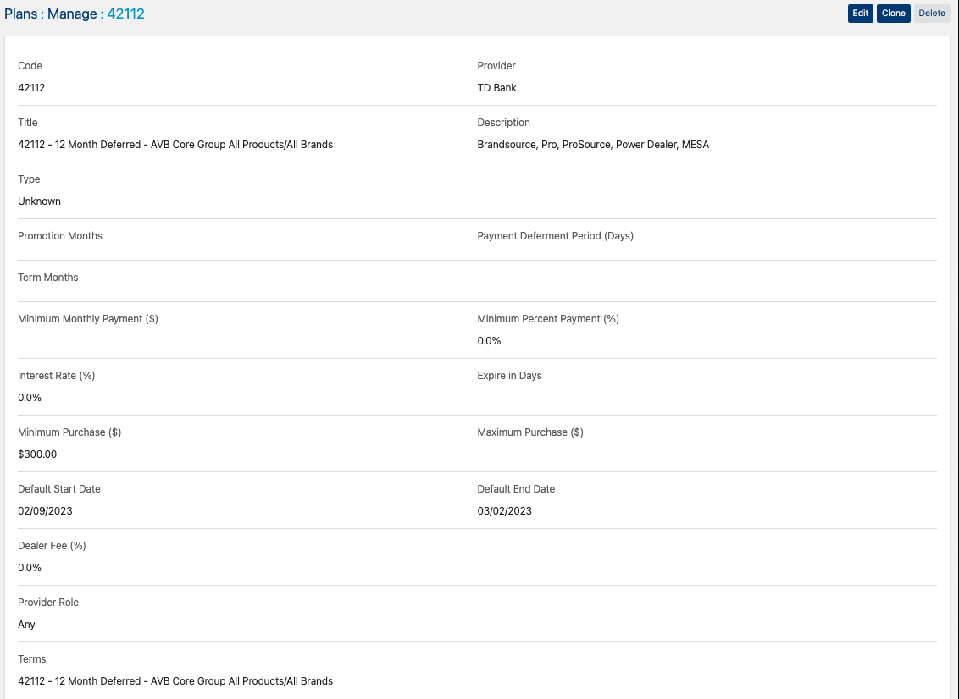

**Assigning Internet Promotions for AVB retailers**

For AVB retailers who have opted into e-commerce there are three plans that need to be assigned to their Internet location.

I do not complete this step still after Doug has completed the configurations and added the keys into console. The reason why I do it this way is I do my final checks before the welcome email is sent.

Go into console and select the retailer you need to add the pplans for.



Once you have accessed the retailer go to the left hand menu and select plans

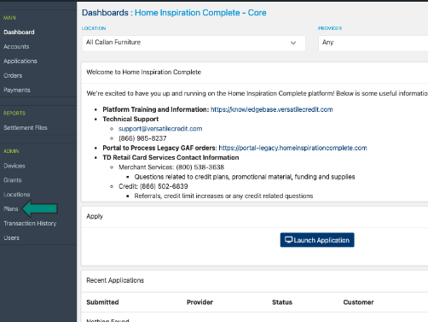

Then Manage Plan Schedule

Should you need to ever see what plans a retailer has made accessible to their stores this is tab you would access.

For example if a retailer calls in and says they cant see a plan, this is where I go to look first.

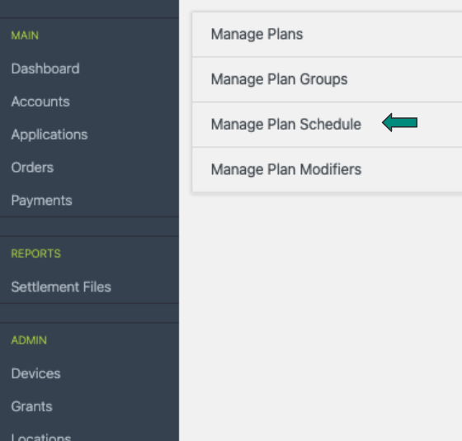

Change the Location to the internet

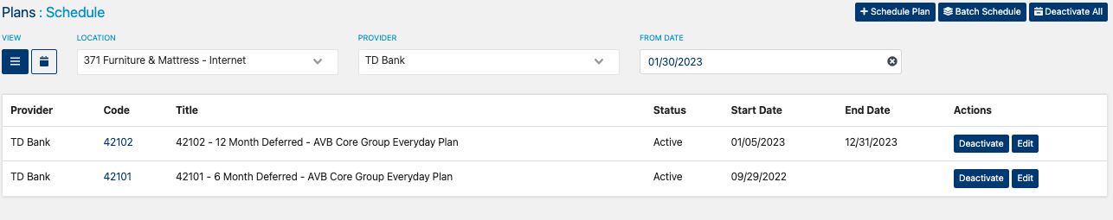

There are only three internet plans that are for internet only

42197

42198

42199

To assign plans click +Schedule Plan

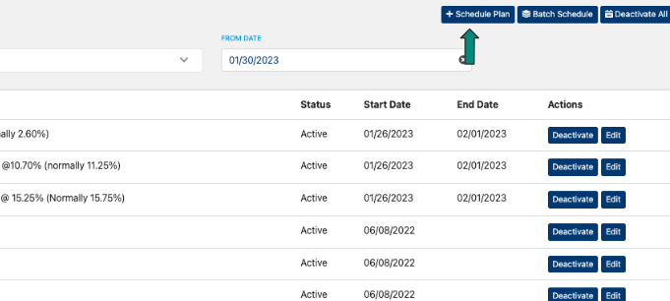

Type in the plan number in the box and click the highlighted plan

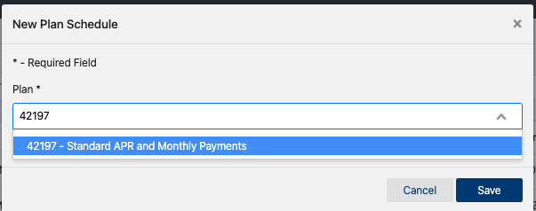

Unlike the in store promotion these plan are revolving you will not need to update the flight dates.

You will need to update the location that these plans are tied to, they need to only be assigned to the internet location.

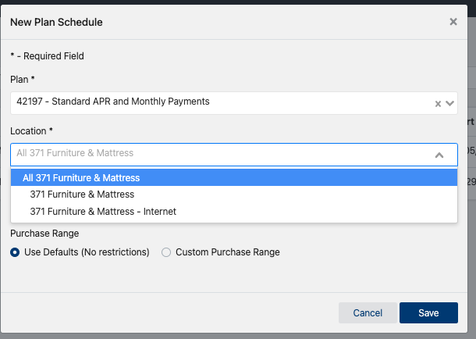

Once you have updated the location, click save

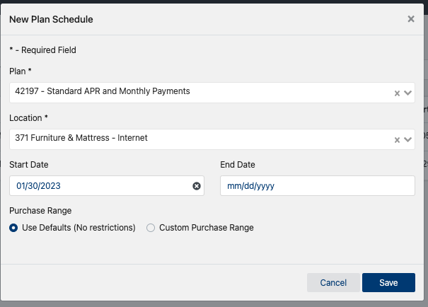

Repeat these steps for the other two promotions.

**HIC Plan Management**

HIC plan management is easier than AVB, we only set up quarterly and holiday specials.

**Things to Know:**

-The quarterly specials are sent by Carolee Moreno at Furniture First.

-You will never have to add new quarterly plans for HIC.

- There will always be 15 days that are selected

- If there are dates that are in the past and Carolee has not given direction in her email on how to handle, disregard those dates.

-To make sure that that the end date is inclusive we must set the end date in the portal to be the following day. Instructions for this are to follow

Example of the email received:

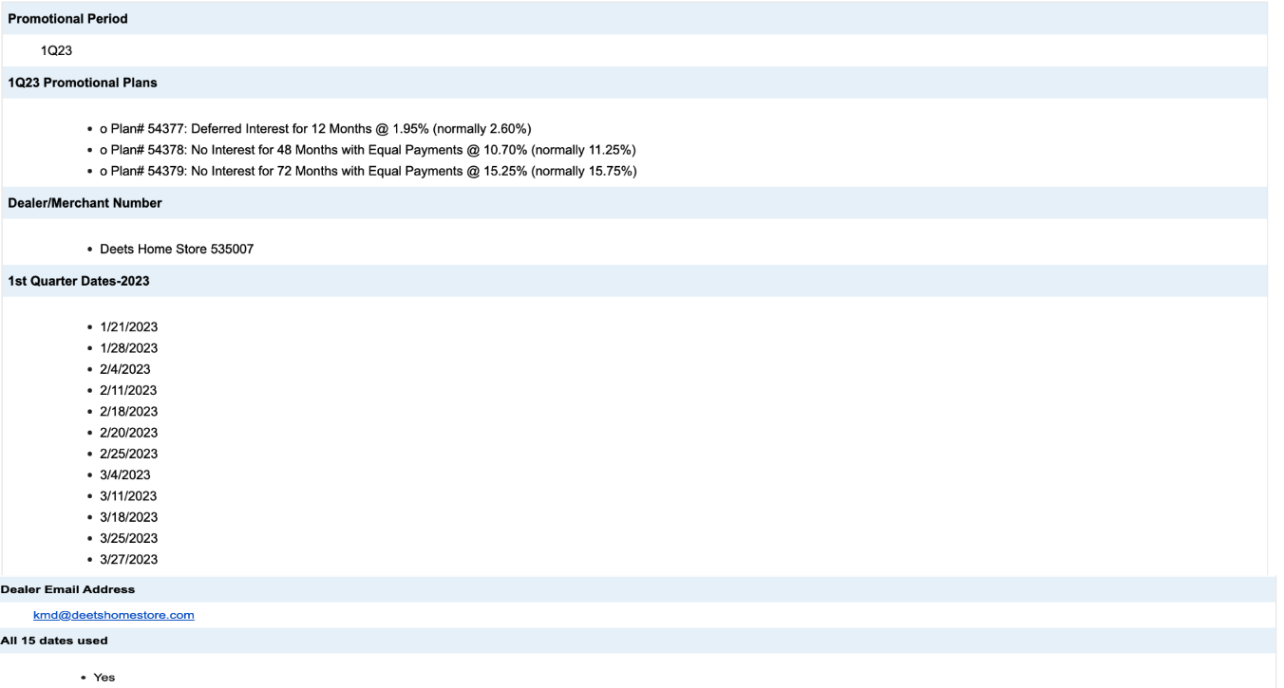

When adding quarterly or holiday specials for HIC members this is completed at the invidivdual retailer domain level in the HIC portal.

After we have received the email from Carolee, go into console and select the retailer you need to add the pplans for.



Once you have accessed the retailer go to the left hand menu and select plans



Then Manage Plan Schedule

Should you need to ever see what plans a retailer has made accessible to their stores this is tab you would access.

For example if a retailer calls in and says they cant see a plan, this is where I go to look first.



All HIC members provider dropdown defaults to AFF on this page, you will need to update this field to show TD Bank.

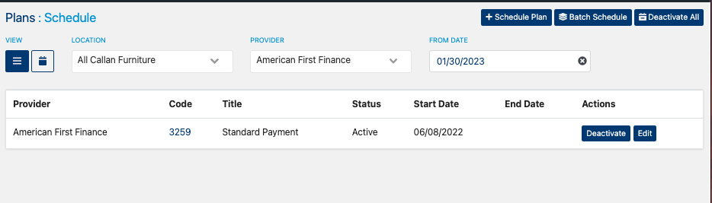

There will be plans that appear already on this page, they could be current quarter plans or their everyday revolving plans.

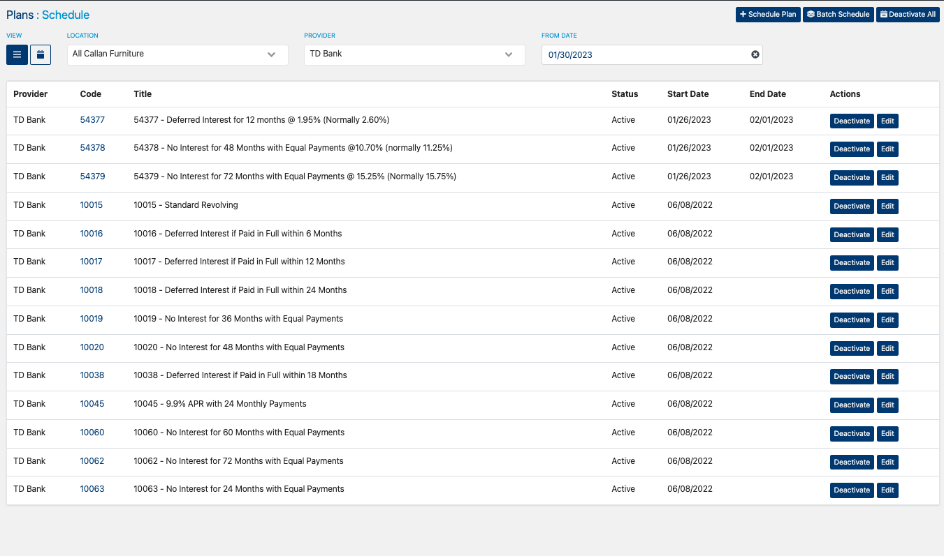

To add plans click + Schedule plan



An iframe box will appear, it is important to remember that being that we are set as super admins you will see all plans for TD Bank this includes plans for AVB. 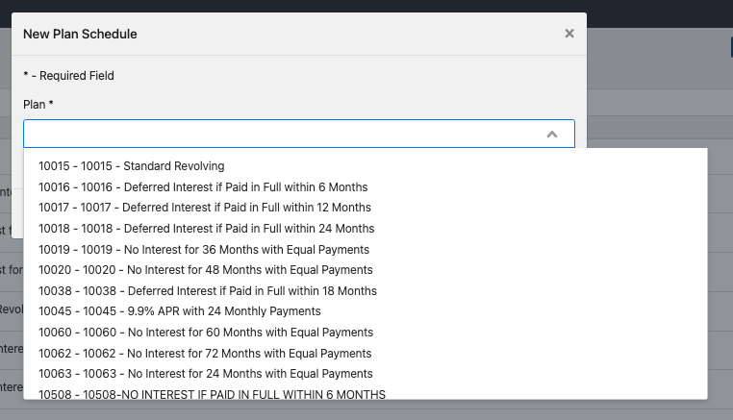

Easiest way to locate a plan is to type the plan code number in the box

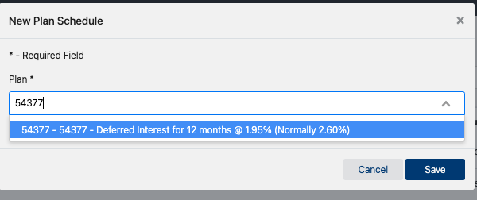

After you select the plan, you can adjust the start and end date.

For HIC retailers you will never have to adjust the location or the rstirctions that are applied to the promotions.

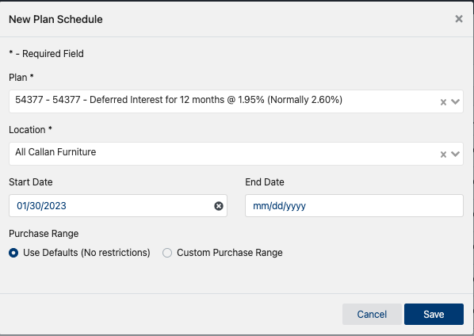

To make sure that the end date that is listed on the email is inclusive, you need to set the end date in the portal to be the following day.

For example on the email example I provided a few pages back the date 1/21/23 is listed. In the portal you will have the start date be 1/21/23 and the end date set to 1/22/23.

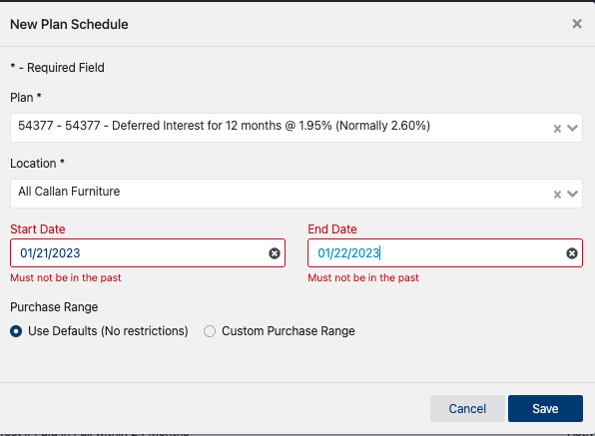

Please disregard the red messages below the dates, I used past dates for demonstration purposes.

You would repat this step for all of the dates listed and for each of the three plans.

If the dates are in consecutive order, for example 2/1,2/2, ⅔, etc that can be one entry.

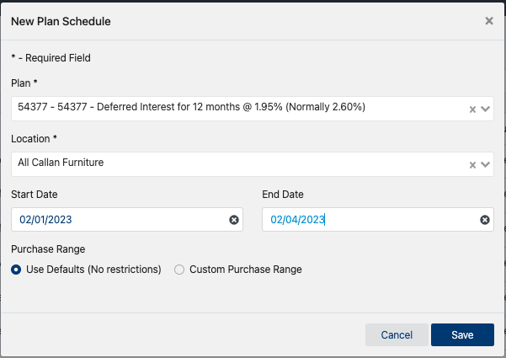

**Activating Additional Lenders - AVB**

**Genesis**

Genesis will send the API needed via email

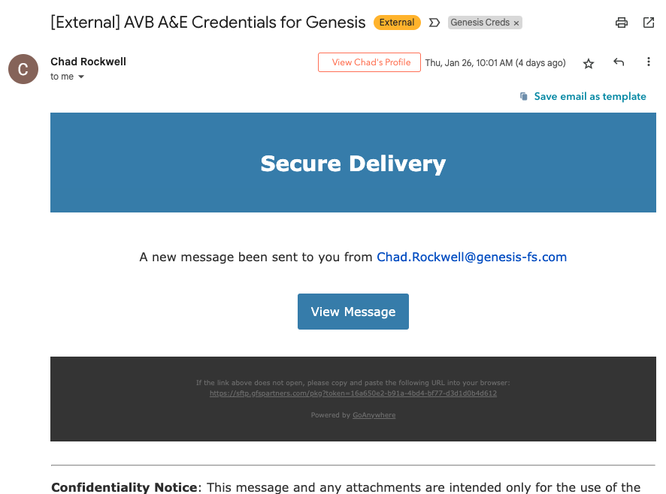

I download the information and enter it on [Additional Provider Sheet](https://docs.google.com/spreadsheets/d/1suew3VCLGNsAMhph6TUN2XBbQAm1QRBLebyue0DD-1Q/edit#gid=854820627)

*The branding GUID, username and PW from Genesis will be the same for all AVB retailers

Send an email out to the retailer asking when they would like to have Genesis activated.

Subject: AVB Complete - Go Live with Genesis

Email body:

Good Morning *Insert Retailer Name Here*

Genesis has been integrated with the AVB Complete portal and the credentials have been delivered from them to activate them for your store.

Do you have a preference on when you would like to have Great American Finance turned on for your store?

Below is a link for a demo sesion that will provide guidance on the application flow as well and the order processing stage.

***I also attached the AVB resource sheet to this thread as well***

After the retailer responds back that they have completed the training video demo you will need to send the credentials over to Doug.

I have created an [activating Genesis template](https://docs.google.com/spreadsheets/d/1DG1iXzIah8ViCfco45qHmxazAJbEQCdR_n4V4K1H2IE/edit#gid=318277055) - This is the same sheet that is used for send Doug the initial onboarding credentials.

Column breakdown:

A - Merchant name : If retailer has more then one location it is easier to copy and paste what name we have them as in console in this column.

B-D: These columns will never change

E - location ID: This will be apart of the credentials that Chad sends and that we added to the tracker sheet

You can duplicate this tab and add the applicable information. You will need to update the tab name if you duplicate it. The tab numbers are in numeric order. After you have all the information entered, you can slack Doug letting him know that V175 (example #) is ready and he will take it from there.

After Doug confirms that the lender has been activated you willneed to assign categories in console for that retailer for the provider. Steps to do that are the same as the ones for adding categories for TD.

From the main versatile page in console, find domains on the left hand menu.

Then search for the retailer where Genesis has been activated, click the hyperlink of their name.



Go to the provider Catgories and click +Add

Genesis will always have 4 categories that need assigned:

Appliances

Automotive

Electronics

Furniture



If this step is missed there will be no categories that appear when the retailer is processing a sales order

**Activating GAFCO**

GAF will deliver the APIs via email, they are sent via zip file. If you do not have this feature downloaded on your laptop. Send the credentials over to Lisa she has this capability as well.

The API sheet will look like the below:

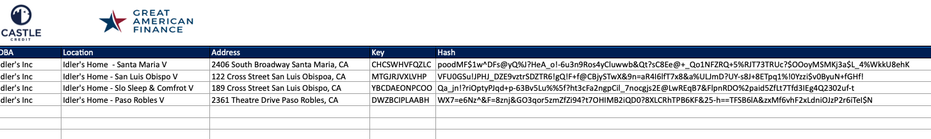

They will need to be added to the Additional Lender Tracker for [GAF](https://docs.google.com/spreadsheets/d/1suew3VCLGNsAMhph6TUN2XBbQAm1QRBLebyue0DD-1Q/edit#gid=1443025278)

Email the Reatiler:

Subject: AVB Complete - Go Live with GAF

Email Body:

Good Morning *Insert Retailer Name Here*

Great American Finance has been integrated with the AVB Complete portal and the credentials have been delivered from them to activate them for your store.

Do you have a preference on when you would like to have Great American Finance turned on for your store?

Below is a link for a demo sesion that will provide guidance on the application flow as well and the order processing stage.

***I also attached the AVB resource sheet to this thread as well***

After the retailer responds back that they have completed the training video demo you will need to send the credentials over to Doug.

I have created an [activating GAFCO template](https://docs.google.com/spreadsheets/d/1DG1iXzIah8ViCfco45qHmxazAJbEQCdR_n4V4K1H2IE/edit#gid=318277055) - This is the same sheet that is used for send Doug the initial onboarding credentials.

Column breakdown:

A - Merchant name : If retailer has more then one location it is easier to copy and paste what name we have them as in console in this column.

B-C: copy and paste the key & Hash that GAF sent

You can duplicate this tab and add the applicable information. You will need to update the tab name if you duplicate it. The tab numbers are in numeric order. After you have all the information entered, you can slack Doug letting him know that V175 (example #) is ready and he will take it from there.

After Doug confirms that the lender has been activated you willneed to assign categories in console for that retailer for the provider. Steps to do that are the same as the ones for adding categories for TD.

From the main versatile page in console, find domains on the left hand menu.

Then search for the retailer where GAF has been activated, click the hyperlink of their name.



Go to the provider Catgories and click +Add

GAFCO will always have 4 categories that need assigned:

Appliances

Automotive

Electronics

Furniture



If this step is missed there will be no categories that appear when the retailer is processing a sales order.

**Activating AFF**

Susanne Bonebroke from AFF will send over the needed tokens via email.

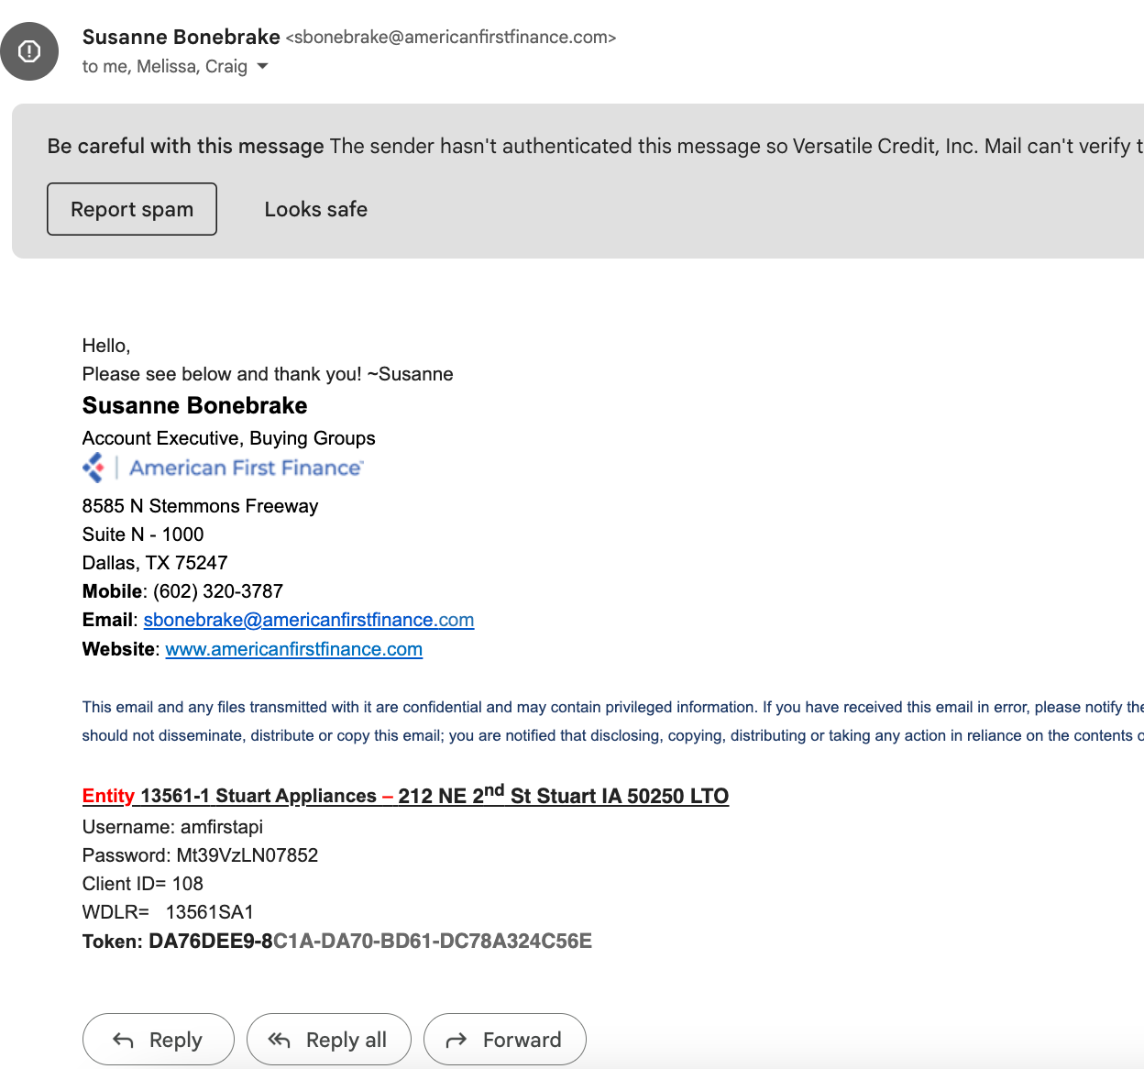

They will need to be added to the Additional Lender Tracker for [AFF](https://docs.google.com/spreadsheets/d/1suew3VCLGNsAMhph6TUN2XBbQAm1QRBLebyue0DD-1Q/edit#gid=131007585)

Email the Reatiler:

Subject: AVB Complete - Go Live with GAF

Email Body:

Good Morning *Insert Retailer Name Here*

American First Finance has been integrated with the AVB Complete portal and the credentials have been delivered from them to activate them for your store.

Do you have a preference on when you would like to have American First Finance turned on for your store?

Below is a link for a demo sesion that will provide guidance on the application flow as well and the order processing stage.

***I also attach the AVB resource sheet to this thread as well***

After the retailer responds back that they have completed the training video demo you will need to send the credentials over to Doug.

I have created an [activating AFF template](https://docs.google.com/spreadsheets/d/1DG1iXzIah8ViCfco45qHmxazAJbEQCdR_n4V4K1H2IE/edit#gid=443051188) - This is the same sheet that is used for send Doug the initial onboarding credentials.

Column breakdown:

A - Merchant name : If retailer has more then one location it is easier to copy and paste what name we have them as in console in this column.

B-C: copy and paste the WDLR & Token provided by AFF

You can duplicate this tab and add the applicable information. You will need to update the tab name if you duplicate it. The tab numbers are in numeric order. After you have all the information entered, you can slack Doug letting him know that V175 (example #) is ready and he will take it from there.

After Doug confirms that the lender has been activated you willneed to assign categories in console for that retailer for the provider. Steps to do that are the same as the ones for adding categories for TD.

From the main versatile page in console, find domains on the left hand menu.

Then search for the retailer where AFF has been activated, click the hyperlink of their name.



Go to the provider Catgories and click +Add

AFF will always have 4 categories that need assigned:

Bed & Mattress

Consumer Electronics & Appliances

Furniture

Tire & Wheel



If this step is missed there will be no categories that appear when the retailer is processing a sales order.

**Activating Progressive**

**Thomas or Trevor will email a spreadsheet that has the needed APIs**

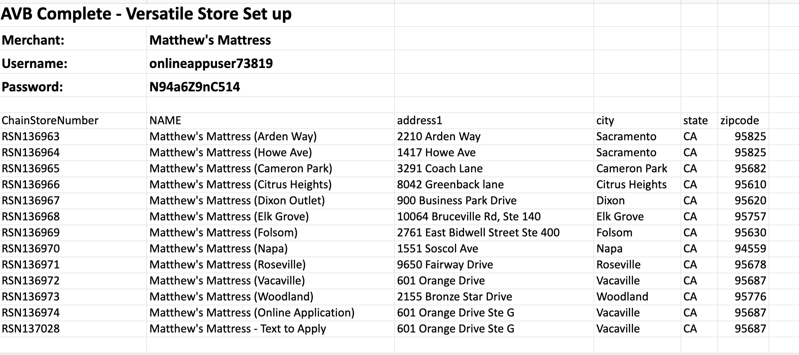

They will need to be added to the Additional Lender Tracker for [Progressive](https://docs.google.com/spreadsheets/d/1suew3VCLGNsAMhph6TUN2XBbQAm1QRBLebyue0DD-1Q/edit#gid=584036684)

Email the Reatiler:

Subject: AVB Complete - Go Live with Progressive

Email Body:

Good Morning *Insert Retailer Name Here*

Progressive has been integrated with the AVB Complete portal and the credentials have been delivered from them to activate them for your store.

Do you have a preference on when you would like to have Progressive turned on for your store?

Below is a link for a demo sesion that will provide guidance on the application flow as well and the order processing stage.

***I also attach the AVB resource sheet to this thread as well***

After the retailer responds back that they have completed the training video demo you will need to send the credentials over to Doug.

I have created an [activating Progressive template](https://docs.google.com/spreadsheets/d/1DG1iXzIah8ViCfco45qHmxazAJbEQCdR_n4V4K1H2IE/edit#gid=443051188) - This is the same sheet that is used for send Doug the initial onboarding credentials.

Column breakdown:

A - Merchant name : If retailer has more then one location it is easier to copy and paste what name we have them as in console in this column.

B-C: copy and paste the Progressive Store ID & Chain Store Number provided by Progressive

You can duplicate this tab and add the applicable information. You will need to update the tab name if you duplicate it. The tab numbers are in numeric order. After you have all the information entered, you can slack Doug letting him know that V175 (example #) is ready and he will take it from there.

After Doug confirms that the lender has been activated you willneed to assign categories in console for that retailer for the provider. Steps to do that are the same as the ones for adding categories for TD.

From the main versatile page in console, find domains on the left hand menu.

Then search for the retailer where AFF has been activated, click the hyperlink of their name.



Go to the provider Catgories and click +Add

Progressive will always have 8 categories that need assigned:

Car Audio & Tire

Electronics

Furniture

Jewelry

Mattress

Service Plan/Warranty

Delivery/Shipping Fee

Wireless



If this step is missed there will be no categories that appear when the retailer is processing a sales order.

**Activating Snap**

Sean Bellotti will send an email notification when the newest APIs are ready in their developer portal. There will also be an attachment on this email that tell you what retailers need to complete their Snap Certification before they can be activated as well as their MID.

[Brad Steiner](mailto:steiner@versatilets.com)will need to download the APIs from the portal and send them to you. He can download all APIs voa a CSV file, any new retailers will be at the very bottom of the list.

When you notify the retailer you will need to send their new MID to them. I have a spreadsheet that I update and download, [AVB - Snap MIDs -](https://docs.google.com/spreadsheets/d/1BTF1oC1twb57U4Gie4Bam88K7dQzTCAlsGKKfh_w0-A/edit#gid=0)  I just attach the attachment in the email.

The APIs will need to be added to the [Additional Lender Tracker](https://docs.google.com/spreadsheets/d/1suew3VCLGNsAMhph6TUN2XBbQAm1QRBLebyue0DD-1Q/edit#gid=0)

Email to Reatilers

Make sure you copy [Sean Bellotti](mailto:sbellotti@snapfinance.com), [Trent Goddard](mailto:tgoddard@snapfinance.com) and [Bridget Cunningham](mailto:bcunningham1@snapfinance.com)

**Retailer does NOT need to complete Snap Certification:**

Subject Line: AVB - Go Live with Snap Finance

Email Body:

Good Morning *Insert Reatiler Name Here*

Snap Finance has been integrated with the AVB Complete portal and the credentials have been delivered from them to activate them for your store. I have attached the MIDs that have been assigned to your locations by Snap.

Do you have a preference on when you would like to have Snap Finance turned on for your store?

Below is a link for a demo sesion that will provide guidance on the application flow as well and the order processing stage.

***I also attach the AVB resource sheet to this thread as well***

**Retailers that DO need to complete the Snap Certification:**

Subject Line: AVB - Go Live with Snap Finance

Email Body:

Good Morning *Insert Reatiler Name Here*

Snap Finance has been integrated with the AVB Complete portal and the credentials have been delivered from them to activate them for your store. I have attached the MIDs that have been assigned to your locations by Snap.

You will need to complete the required Snap training as part of the certification with Snap Finance. You can access the training/certification through this link [Snap Certification Link](https://snapfinance.qwilr.com/-BrandSource-AVB-Get-Snap-Certified-7JmoDjQOTgaX)

After you have completed your training with Snap you can advise what day you would like Snap to be activated for your store.

Below is a link for a demo sesion that will provide guidance on the application flow as well and the order processing stage.

***I also attach the AVB resource sheet to this thread as well***

After the retailer responds back that they have completed the training video demo you will need to send the credentials over to Doug.

I have created an [activating Snap template](https://docs.google.com/spreadsheets/d/1DG1iXzIah8ViCfco45qHmxazAJbEQCdR_n4V4K1H2IE/edit#gid=443051188) - This is the same sheet that is used for send Doug the initial onboarding credentials.

Column breakdown:

A - Merchant name : If retailer has more then one location it is easier to copy and paste what name we have them as in console in this column.

B-C: copy and paste the Client ID & Secret that were downloaded from the Snap developer portal

You can duplicate this tab and add the applicable information. You will need to update the tab name if you duplicate it. The tab numbers are in numeric order. After you have all the information entered, you can slack Doug letting him know that V175 (example #) is ready and he will take it from there.

You do not need to assign categories for Snap.

**TDC**

**TDC Credentials**

Credential Emails will be delivered by Hannah Etheridge or Natalia Herrera

Example below

*Its easier if you open then in google sheets

First thing I do when I open the sheet is hide columns F & H - we dont need them



**Setting up a new Domain in** [**TDC**](https://portal.tdcomplete.com/#/admin/domains)

Make sure that you are on the domains tab. Click +Add Domain in the upper right hand corner

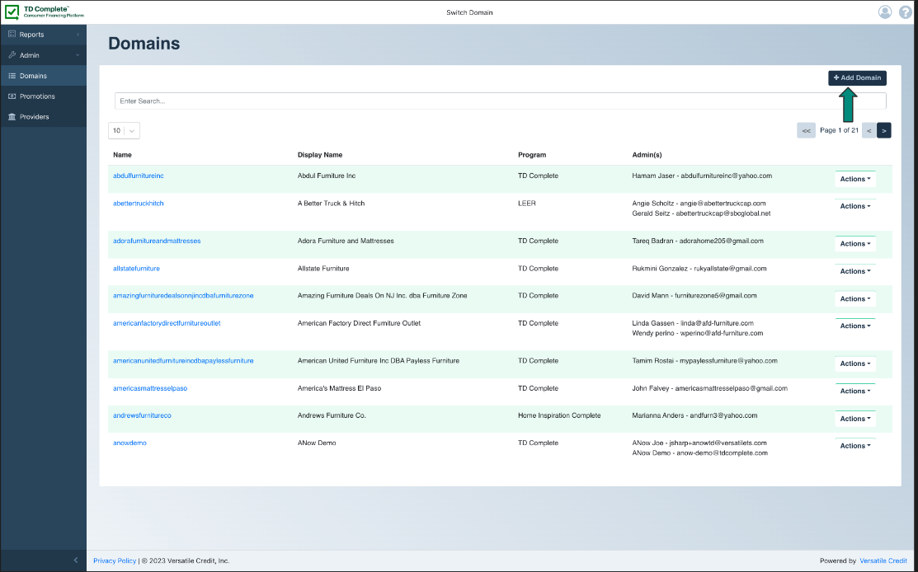

An iframe box will appear you will need to enter the information in the field below:

Name: This is where you will eneter th retailer name

Program: Select if they are TDC or Leer

Merchant Name: You can copy and paste whatever information you entered for the name field here

First name of Primary Admin: This is gotten from the TD credential sheet

Last name of primary Admin: This is gotten from the TD credential sheet

Email of Primary Admin: This is gotten from the TD credential sheet

Password: To assign a temporary password click generate then show password.

This will need to pasted into the welcome email.

Providers: Make sure you select TD Bank

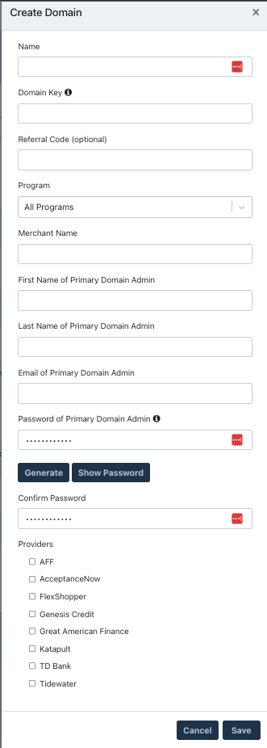

**For TDC you can not add additional locations until you have the admin keys.**

Sending the credentials to Doug you will use this [Sheet](https://docs.google.com/spreadsheets/d/1PJLI62WLkgqQ6mY4knv4eRGLXM6bZ7FcQ-nNMa5vV8g/edit#gid=1949858220)

I have create a template for adding new TDC/Leer/HIC retailers as well as adding PFP locations.

Column Breakdown:

A&B: These columns are for where Doug will enter the S2A and portal keys.

C: Specify what program TDC, Leer, HIC

D: Merchant Name: Copy and Paste the same name you used to set up the retailer. If the retailer has additional locations I do the retailer name followed by a dash then the town name. If the retailer has two locations in the same town use the street name instead.

E: Address: This can be copy and pasted directly from teh sheet TD provides.

F-I: these fields can be copy and pasted directly from the sheet TD provides and they have the same naming conventions

You can duplicate the template but you will need to update the tab name. The tabs go in numeric order.

If the retailer has more then one location Doug will need to confirm with you when the configuration is complete so that you can add the additional locations to TDC.

PFP Locations

Kelley Espsito will send an email saying that a location can be added to the portal.

There will be an attachment that contains the store number and what PFP merchant number should be tied to the location.

Confirm back to Kelley that we will confirm when the location has been added to the portal.

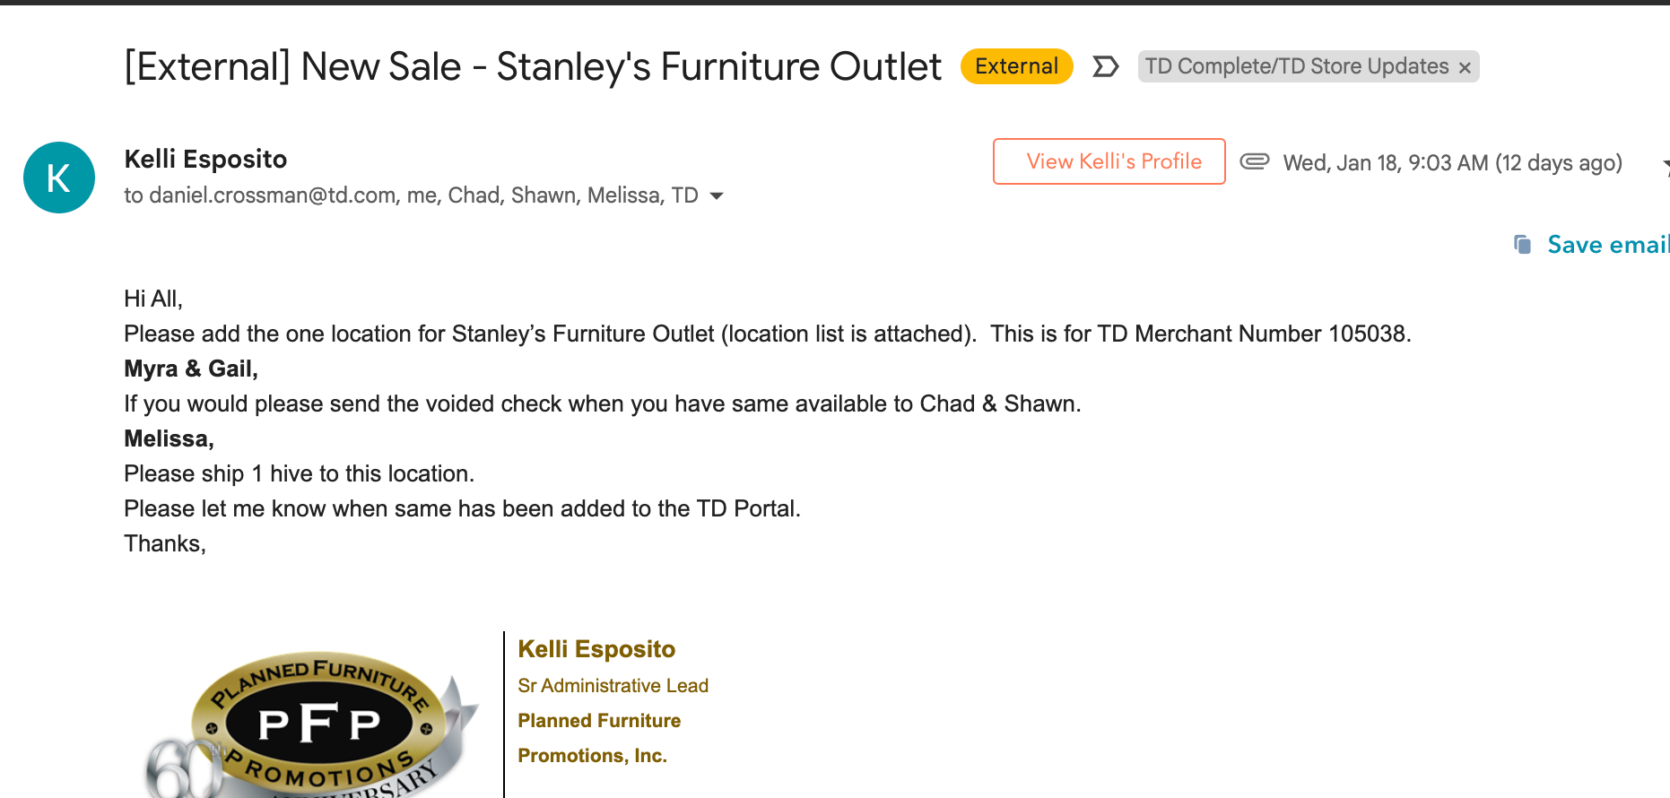

The attachment that is on the email:



The credentials will need to be sent to Doug using this [sheet](https://docs.google.com/spreadsheets/d/1PJLI62WLkgqQ6mY4knv4eRGLXM6bZ7FcQ-nNMa5vV8g/edit#gid=1578882616)

Coulmns Breakdown:

A&B: These columns are for where Doug will enter the S2A and portal keys.

C: Merchant Name: Copy and Paste the same name you used to set up the retailer. If the retailer has additional locations I do the retailer name followed by a dash then the town name. If the retailer has two locations in the same town use the street name instead.

D: Specify what program this would be PFP

E - Address: This can be copy and pasted directly from the sheet Kelley provides.

F&G: Are the Store # and Merchant number, these are on the email attachment that Kelley Sends.

This tab can be duplicated but you will need to update the name. The tabs go in numeric order.

Doug will need to confirm when the configuration is complete so that this location can be added in the portal.